**PROJECT TITLE:**

Analysis of Dota 2 Matches

**Group Members :**

**1. Piyush Singhania**

**2. Sarthak Tripathi**

**3. Aman Garg**

**4. Javid Akhtar**

**Project Description:**

We are analysing several hundreds of thousands of Dota 2 Matches using Machine Learning to help aspiring Dota 2 Players in counter picking heroes through the correct analysis. We shall draw our conclusions depending on the

* Win rate of each hero in the game as compared to the other opposing heroes.
* By determining the advantage percentage of a hero against all others by comparing XP/Gold per minute of a player.
* Taking players MMR Ranking into account.

Total Number Of Entities used in the Database Model - 11

1. Match
2. Item
3. Players
4. Ability_Upgrade
5. Chat
6. Team_Fights
7. Ability_Id’s
8. Hero_Names
9. TeamFights_Players
10. Purchase_Logs
11. Objectives.

**ER DIAGRAM**

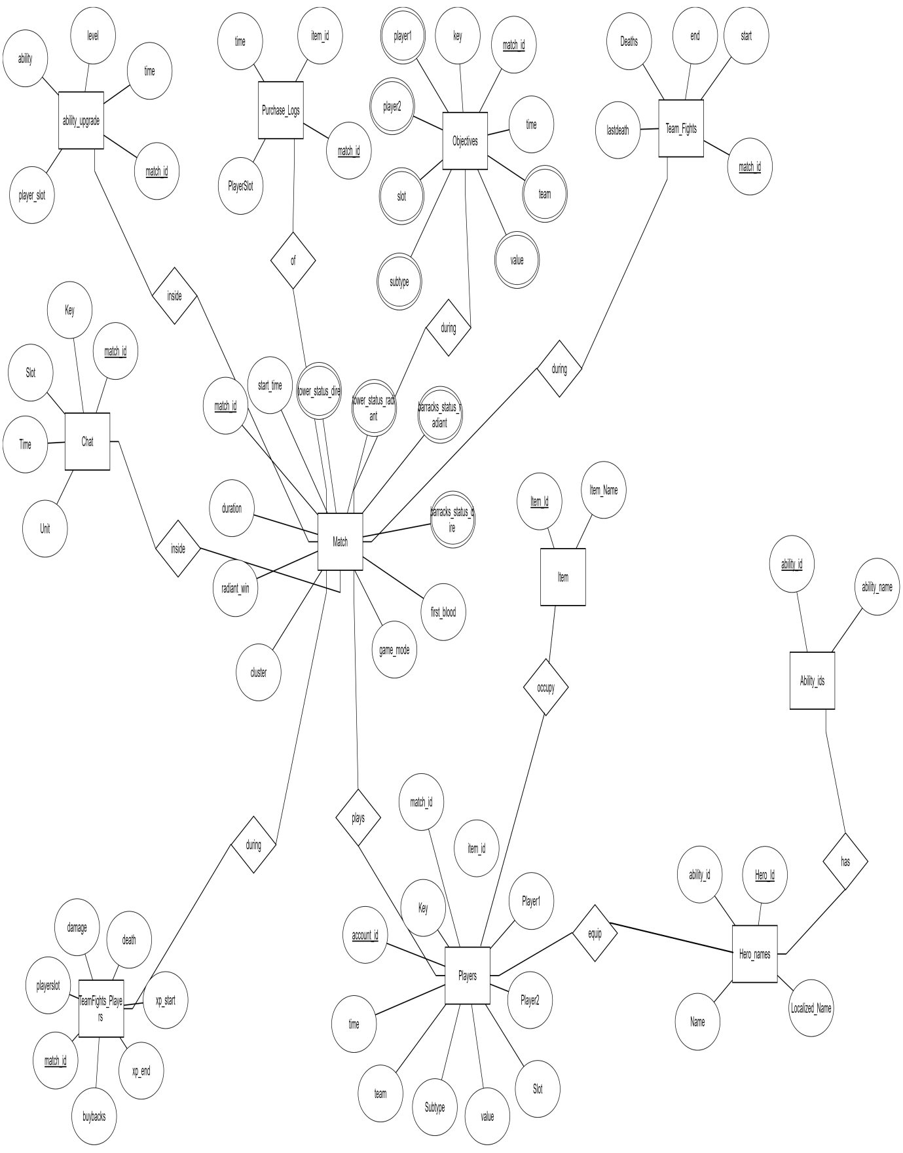

**RELATIONAL SCHEMA OF DATABASE**

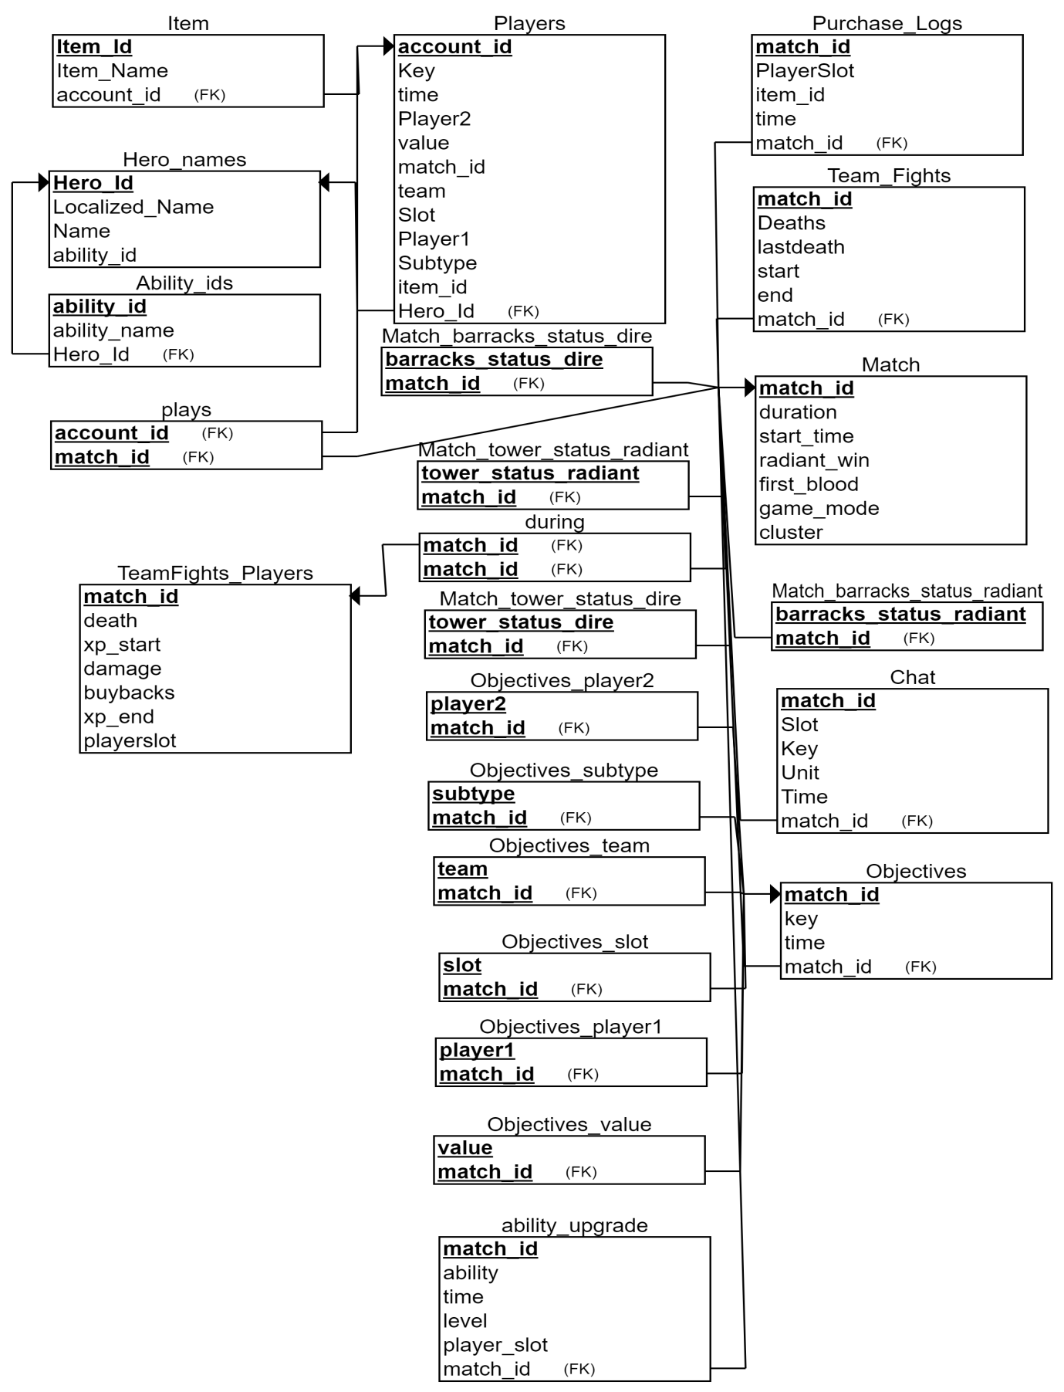

**FD’s**

1. Hero -> Ability_ID
2. Ability Upgrades -> Ability_ID
3. Match ID --> Duration
4. Players -> Objectives
5. Gold -> Item Purchases
6. Player -> Chat
7. Player -> Hero
8. Hero -> Damage
9. Hero -> GPM
10. Hero -> XPM
    1. https://ssl.gstatic.com/ui/v1/icons/mail/images/cleardot.gif